**INSTRUCTIONS**

For this round, there are 2 sections.

Section - A with basic programming with 7 questions

Section - B with puzzle based programming.

You can use **any language** for programming. But stick to one language for all the questions.

Add proper comments for each function/logic code you are writing.

**How to submit?**

**1)Via Github**

* Upload the code to your github repository
* Make sure that your github repo is publicly accessible
* While filling the below form, mention the github repo link.
* Add proper README.md file

**2)Via Zip**

* Create one folder for section A and another folder section B.
* Name the solutions with proper file name
* Zip all your solutions and upload it.

Submit your response at the link <https://zfrmz.com/TfbP5VtG0QiCx5TLdiX2>

**Note :** It is not mandatory to finish all the questions. Submit the answers of what ever questions you have done, on before the 10th April 2022.

**Section A : Logical Programming Questions**

Question 1:

Display the diagonal pattern for the string of odd length.

**Sample** **Input 1:**

Enter the string : racecar

**Sample Output 2:**

e

c c

a a

r r

a a

c c

e

**Sample Input 2 :**

Enter the string : football

**Sample Output 2:**

Not Possible

Question 2 :

Print the following pattern for the given n:

**Sample Input 1:**

Enter the number = 3

**Sample Output 2:**

1 6 5

2 4

3

**Sample Input 2:**

Enter the number = 5

**Sample Output 2:**

1 12 11 10 9

2 13 15 8

3 14 7

4 6

5

Question 3 :

Print the largest possible for the given string.

**Sample Input:**

Enter the number of string to be entered = 2

Enter the string1 : abdf

Enter the string2 : hafd

**Sample Output:**

String1 : fdba

String2 : hfda

Question 4:

Print the following pattern for the given input.

Input:

Enter the number : 5

Output:

5 5 5 5 5 5 5 5 5

5 4 4 4 4 4 4 4 5

5 4 3 3 3 3 3 4 5

5 4 3 2 2 2 3 4 5

5 4 3 2 1 2 3 4 5

5 4 3 2 2 2 3 4 5

5 4 3 3 3 3 3 4 5

5 4 4 4 4 4 4 4 5

5 5 5 5 5 5 5 5 5

Question 5:

Check whether the given string has characters of equal difference or unequal difference.

**Sample Input 1:**

Enter the string : abcdefg

**Sample Output 1:**

Equal difference.

**Sample Input 2:**

Enter the string : adxz

**Sample Output 2:**

Unequal difference.

**Explanation:**

Sample Input 1 :

string = abcdefg

| b - a | = | f - g | = 1

| c - b | = | e - f | = 1

| d - c | = | d - e | = 1

Since the difference between the characters are same throughout i.e 1, therefore the given string is unique.

Sample Input 2 :

string = adxz

| d - a | ! = | x - z |

Since the difference between the characters (d - a) and (x - z) are not equal, therefore the given string is not unique.

Question 6:

Find one of the maximum possible palindrome in the given string.

Input:

Enter the string : madameaga

Output:

aamdmaa

Input:

Enter the string : abcdefghfgbeadc

Output:

abcdefghgfedcba

Question 7:

Print the distinct words in the given string.

**Sample Input 1:**

Enter the string : This is Zoho and Zoho is good

**Sample Output 1:**

The distinct words are : This is Zoho and good

**Sample Input 2:**

Enter the string : we develop software we craft software

**Sample Output 2:**

The distinct words are : we develop software craft

**SECTION B - PUZZLE BASED PROGRAMMING**

In this section, each question will be a continuation of the earlier one.

The following problems revolve around an adventurer who enters a dungeon in search of Gold (Treasure). The objective for all the questions will be to find the quickest path to the Gold without bringing harm to the adventurer. In each question, we will edit or bring in new elements to the dungeon (an underground prison cell). Your task is to find the shortest path for the adventurer to get the Gold which can be located anywhere in the dungeon. (The location of the Gold will be given in the input).

In each **turn** the adventurer(the person who goes to get the gold in the dungeon) can move **one step (right, left, up, down)**. A single cell can be occupied by both adventurer and Gold (i.e. any number of items can be available in a cell).

In the sample box(dungeon area) given below, 'A' refers to the adventurer and 'G' refers to the Gold.

1 2 3 4

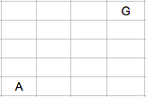

Question 1

Task: To find the minimum number of steps required to reach the Gold.

Rules:

1) The adventurer can move only left, right, up and down.

2) The adventurer can only move within the dungeon.

**Note**:- The size of the dungeon will be given during input.

Example:

1 2 3 4

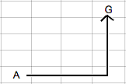

If 'A' and 'G' are placed at (5,1) and (1,4) respectively then the path shown above is the shortest path the adventurer can take to reach the Gold. The shortest path taken in the above dungeon is: [5,1 -> 5,2 -> 5,3 -> 5,4 -> 4,4 -> 3,4 -> 2,4 -> 1,4]. Therefore the minimum number of steps is 7.

Sample Input:

Dimensions of the dungeon(Row x Column): 5 4

Position of adventurer: 5 1

Position of gold: 1 4

Sample Output:

Minimum number of steps: 7

Question 2

A monster (M) will be introduced in the dungeon. The monster's aim is to prevent the adventurer from getting the gold. It will move in the best way possible to achieve this (i.e. if the monster can reach gold before the adventurer, then the monster can prevent the adventurer from getting gold). The monster will move only after the adventurer makes his move.

Note:-

1) The monster may or may not move every turn(every time the adventurer moves).

2) Both the monster and the adventurer know each other's location.

Task: To find the minimum no of moves, so that the adventurer can reach the gold without dying.

Examples:

1 2 3 4

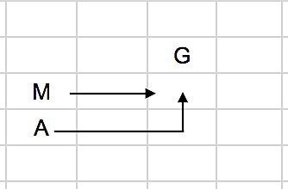

In the given example, by the time the adventurer tries to reach the gold, the monster would have killled the adventurer. When the adventurer starts from (4,1) and reaches (3,3), the monster would have reached that location (3,3) already and then kill our adventurer. Even if the adventurer tries to move around the monster, he'll never reach the gold. So, in this scenario there is no possible solution.

1 2 3 4

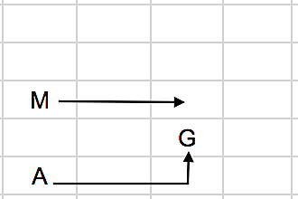

In the above example, after 2 turns A's location is (5,3) and M's location is (3,3). Since A moves first, A will reach the gold before M kills him. Therefore, it is A's victory and the minimum number of moves taken by A is 3.

**Note**:- If there is no solution, the output should be "No possible solution"

Sample Input 1:

Dimensions of the dungeon(Row x Column): 5 4

Position of adventurer: 4 1

Position of monster: 3 1

Position of gold: 2 3

Sample Output 1:

No possible solution

Sample Input 2:

Dimensions of the dungeon(Row x Column): 5 4

Position of adventurer: 5 1

Position of monster: 3 1

Position of gold: 4 3

Sample Output 2:

Minimum number of steps: 3

Question 3

Task: To print the path that the adventurer takes to reach the gold in the minimum number of steps.

Note:- In this case, if there is no solution, then the path is not required.

Example

1 2 3 4

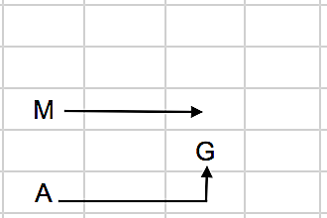

In the above figure the path taken by the adventurer is: (5,1) -> (5,2) -> (5,3) -> (4,3)

Sample Input:

Dimensions of the dungeon(Row x Column): 5 4

Position of adventurer: 5 1

Position of monster: 3 1

Position of gold: 4 3

Sample Output:

Minimum number of steps: 3

Path: (5,1) -> (5,2) -> (5,3) -> (4,3)

Question 4

In this dungeon, "Triggers" are available. The trigger can completely **kill** the monster when activated. To activate the trigger, the adventurer must go to the location of the trigger in the dungeon. After killing the monster, the adventurer can go to the gold without fear from the monster.

Task: To find the minimum no of steps, required by the adventurer to reach the gold without dying.

Examples:

1 2 3 4

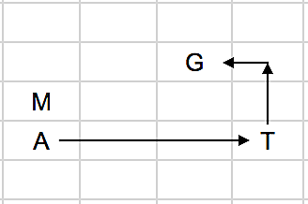

In the above scenario, if the adventurer takes the quickest route to the gold, he will invariably be killed by the monster. To get the gold, he first activates the trigger. After killing the monster, he then takes the shortest path to the gold. This would be the best path for the adventurer. The number of steps taken is: 6

1 2 3 4

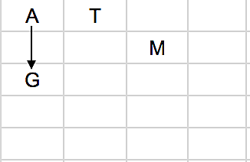

In the above scenario, the adventurer can either go activate the trigger to kill the monster or can go to the gold. But the quickest way to reach the gold would be to go directly to the gold instead of using the trigger. The path taken by the adventurer to use the minimum number of steps is given in the above figure.

Sample Input 1

Dimensions of the dungeon(Row x Column): 5 4

Position of adventurer: 4 1

Position of monster: 3 1

Position of trigger: 4 4

Position of gold: 2 3

Sample Output 1

Minimum number of steps: 6

Sample Input 2

Dimensions of the dungeon(Row x Column): 5 4

Position of adventurer: 1 1

Position of monster: 2 3

Position of trigger: 1 2

Position of gold: 3 1

Sample Output 2

Minimum number of steps: 2

Question 5

This dungeon will **not** have any monsters nor triggers. Though in this dungeon, the adventurer is challenged with **deadly pits**. He must avoid the pits, else he will fall to his death.

Task: To find the minimum no of steps, required by the adventurer to reach the gold without dying.

In this dungeons, pits need to be avoided by the adventurer. Pits are represented by '**P**'.

Note:- There are no monsters in this dungeon.

Examples

1 2 3 4

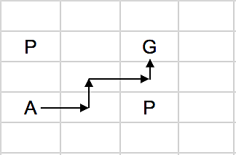

In the above example, the adventurer finds the quickest way to reach the gold while avoiding the pits.

1 2 3 4

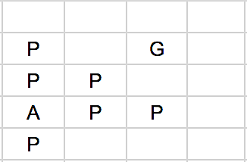

In this example, the adventurer is unable to reach the gold since he is surrounded by pits. Thus the result/output to this input will be "No possible solution".

Sample Input 1:

Dimensions of the dungeon(Row x Column): 5 4

Position of adventurer: 4 1

Position of gold: 2 3

Enter number of pits: 2

Position of pit 1: 2 1

Position of pit 2: 4 3

Sample Output 1:

Minimum number of steps: 4

Sample Input 2:

Dimensions of the dungeon(Row x Column): 5 4

Position of adventurer: 4 1

Position of gold: 2 3

Enter number of pits: 6

Position of pit 1: 2 1

Position of pit 2: 3 1

Position of pit 3: 3 2

Position of pit 4: 4 2

Position of pit 5: 4 3

Position of pit 6: 5 1

Sample Output 2:

No possible solution

Question 6

The monsters have once again begun to appear in this dungeon.

Task: To find the minimum no of steps, required by the adventurer to reach the gold without dying.

In this dungeon,

i) the monsters can walk over the pit.

ii) the adventurer will die if he enters a pit.

Examples

1 2 3 4

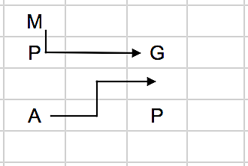

In the above example, the monster has beaten the adventurer to the gold. Hence, there will be no way for the adventurer to get the gold now. For this problem there is no solution.

1 2 3 4

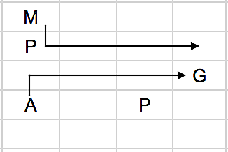

In the above scenario, the adventurer is able to reach the gold even if the monster is able to walk through pits. So, the number of steps it takes for the adventurer to reach the gold is 4.

Sample Input 1

Dimensions of the dungeon(Row x Column): 5 4

Position of adventurer: 4 1

Position of monster: 1 1

Position of gold: 2 3

Enter number of pits: 2

Position of pit 1: 2 1

Position of pit 2: 4 3

Sample Output 1

No possible solution

Sample Input 2

Dimensions of the dungeon(Row x Column): 5 4

Position of adventurer: 4 1

Position of monster: 1 1

Position of gold: 3 4

Enter number of pits: 2

Position of pit 1: 2 1

Position of pit 2: 4 3

Sample Output 2

Minimum number of steps: 4

Question 7

This dungeon includes elements from all the previous dungeons, namely: Pits, Monster and the Trigger.

Task: To find the minimum no of steps, required by the adventurer to reach the gold without dying.

Note:- The monster can walk through pits

Example

1 2 3 4

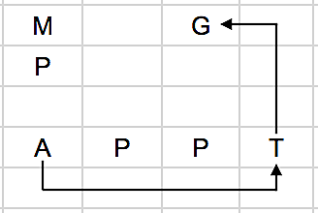

In the above scenario, if the adventurer goes for the gold directly, then the monster will kill him. So, the adventurer first goes to the **trigger** (trigger will kill the monster) and then go for the gold. For this scenario, the minimum number of steps the adventurer can take is 9 steps.

Sample Input

Dimensions of the dungeon(Row x Column): 5 4

Position of adventurer: 4 1

Position of monster: 1 1

Position of trigger: 4 4

Position of gold: 1 3

Enter number of pits: 3

Position of pit 1: 2 1

Position of pit 2: 4 2

Position of pit 3: 4 3

Sample Output

Minimum number of steps: 9